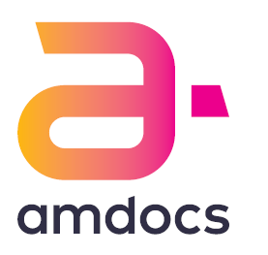

If you’re a smartphone user then you are part of an ever more connected and digital world. At Amdocs, we are leading the digital revolution into the future. From virtualized telecommunications networks, Big Data and Internet of Things to mobile financial services, billing and operational support systems, we are continually evolving our business to help you become more connected. We make sure that when you watch a video on YouTube, message friends on SnapChat or send your images on Instagram, you get a great service anytime, anywhere, and on any device. We are at the heart of the telecommunications industry working with giants such as AT&T, Vodafone, Telstra and Telefonica, helping them create an amazing new world for you where technology is being used in amazing new ways every single day.

We are currently looking to expand our Cyprus site, which is based in Limassol and we are looking for candidates, recent graduates that is, that would like to join our team. With many vacancies currently available in various IT areas, you might find the opportunity that you always wanted. Career starts with a big step. Make it at Amdocs!

To become members of our family, check our current vacancies and apply via jobs.amdocs.com

